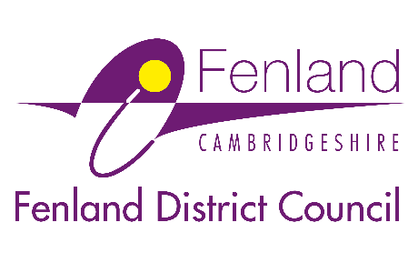

Press Release

29 May 2026

Your Fenland, your say! Further opportunity to help shape the future of the district up to 2050
Fenland District Council has relaunched its consultation on the new Fenland 50 Local Plan, giving residents, businesses and community groups a further chance to help shape the future of the district.

Fenland 50 is the new Local Plan for the district, looking ahead to 2050. It will guide how Fenland grows and changes over the coming decades, covering homes, jobs, infrastructure and the places people live, work and spend time.

A scoping consultation is the vital first-stage in the plan-making process. It asks for early views to help:

- Identify key priorities for Fenland’s future
- Understand what matters most to local people
- Shape how the Council works with communities and stakeholders as the plan develops over the next few years

At this stage, it’s about setting the direction of the plan before detailed ideas are developed.

The scoping consultation was originally held from 28 January to 23 March 2026. It has now been relaunched from 29 May to 29 June 2026 in line with the latest Government plan-making guidance, to provide a further opportunity for people to take part.

A Fenland District Council spokesperson said: “The Local Plan will influence almost every aspect of life in Fenland over the next 25 years, from where new homes are built to how green spaces are protected, how people travel, and where future jobs and services are located. Taking part now means your views help set the foundations of the plan from the very beginning. It is a chance highlight what you value, what you want to see change, and what you want to protect for future generations.”

Taking part in the consultation

To take part in the consultation, visit: www.fenland.gov.uk/Fenland-50-Scoping-Consultation
If you took part in the earlier consultation, you do not need to respond again. Your views have already been captured and will guide the next steps. This relaunch is about making sure everyone has the chance to get involved from the start.

The Council would like to hear from anyone who lives, works or goes to school in Fenland, and is especially keen to hear from younger residents as their priorities will help shape a plan that works for them in future.

The consultation closes at 6pm on Monday 29 June 2026.
Ends

Notes to Editors
For media enquiries, please contact the Fenland District Council press office on 01354 622226 or email: communications@fenland.gov.uk

