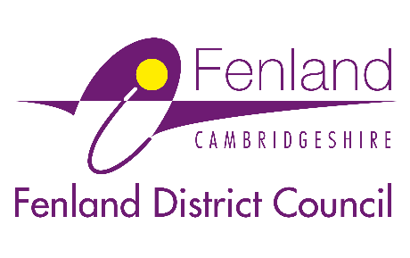

Press Release

5 March 2026

Council launches ‘call for sites’ to help shape new Fenland 50 Local Plan
Invitation to suggest land for potential development and nominate local green spaces of community value in Fenland
Fenland District Council has launched a ‘call for sites’ consultation as the next major step in developing its emerging Local Plan gets underway.
The new plan, known as Fenland 50, will guide how Fenland grows and changes up to 2050, influencing where new homes and jobs go, how towns and villages develop, how flood risk is managed, and the quality of new development.
The call for sites, a statutory and vital early stage in the plan-making process, invites landowners, developers, community groups, and residents to suggest land that could potentially be included in the plan to help meet the area’s future needs.”
Sites can be put forward for various uses, including housing, employment, retail and leisure, commercial, renewable energy, public open space and biodiversity land, infrastructure, mixed-use developments, and any other type of land use.
Alongside the call for sites, the Council is also asking the public to submit nominations for ‘Local Green Space Designation’ in the local plan. This provides open spaces with particular importance to local communities with special protection against new development.
The call for sites and local green spaces designation consultation is open for eight weeks, from Thursday 5 March to Thursday 30 April.
To find out more and submit a site for consideration, visit: fenland.gov.uk/Fenland-50-Call-For-Sites-2026
Cllr Dee Laws, Fenland District Council’s Portfolio Holder for Planning, said: “The call for sites is a crucial process that helps councils with planning responsibilities to identify the land needed to meet nationally imposed housing targets.
“By inviting people to put forward sites for potential development, and nominate local green spaces at this early stage, we can build a Local Plan that helps us meet these targets while reflecting the needs of our communities and supporting sustainable growth.
“We want this process to be open, transparent, and shaped by local knowledge. Whether a site is large or small, for employment, homes, or open space, we encourage people to come forward and help us create an evidence-based plan for the years ahead.”
All potential sites must be submitted as part of this new process, even if they were previously submitted to the Council under the former Local Plan. Only sites received through this consultation will be considered for assessment in the Fenland 50 Local Plan.
Submitting a site does not guarantee that it will be allocated in the Local Plan but ensures it can be fully assessed as part of the plan’s development. Any sites that are proposed for inclusion will be subject to public consultation at key stages of the plan-making process.
Scoping Consultation
In January 2026, the Council launched the first stage of public engagement on the Local Plan – the scoping consultation – which remains open until Monday 23 March.
This simple survey asks what people value about Fenland, what they think needs to improve, what kind of places they want their towns and villages to become, and what should guide decisions about future development. It also asks how people would like to be involved as the plan is prepared.
To take part, visit: surveymonkey.com/r/fenland50
Ends

Notes to Editors
For media enquiries, please contact the Fenland District Council press office on 01354 622226 or email: communications@fenland.gov.uk

