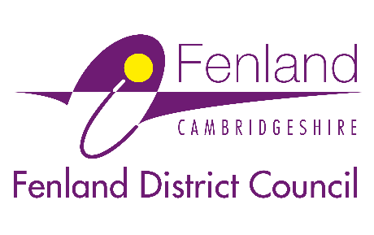

Press Release

19 January 2026

Recruitment event announced for new food waste recycling service
Fenland District Council is holding a recruitment day this month as part of preparations for its new food waste recycling service launching this summer.
Up to 20 new jobs will be available from April, including refuse drivers and operatives.
The recruitment day is on Saturday 24 January, from 10am–2pm, at the Council’s environmental services depot at The Base, Melbourne Avenue, March, PE15 0EN.
Anyone interested in finding out more about the opportunities is welcome to attend. Just drop in at any time and report to reception, no prior booking is required.
Applications for the job vacancies will go live on the day, and attendees will have the opportunity to:
- Find out more about the roles
- Meet members of the waste and recycling team and ask any questions
- Learn more about the new food waste collections and existing waste services
- See the facilities at The Base
- Find out more about employee benefits and clothing and PPE provided
The Council is launching the free, weekly food waste collections in June 2026 to meet new Government legislation, which requires all councils to introduce separate food waste collections this year.
The service will allow residents in Fenland to recycle their food waste for the first time, turning leftovers and scraps into renewable energy and fertiliser for farmers.
By reducing the amount of waste sent to landfill, the service will also help the Council avoid expensive landfill tax and high disposal costs, saving money in the long term. It will free up space in household green bins and, with weekly collections, there’ll be less smell from rotting food too!
Councillor Steve Tierney, Fenland District Council’s Portfolio Holder for waste and recycling, said: “The introduction of food waste recycling is great news for Fenland. It will help residents recycle more, free up space in their green bins, and is better for the local environment than going to landfill or energy from waste.
“We’re pleased that rolling out this service will also create new job opportunities, and we’re keen to welcome new team members who can add value to our service. The recruitment day is a great opportunity for people to find out more about the roles, see our facilities, and talk to members of the team about working with us.”
The closing date for applications is Monday 23 February. Interviews are due to take place week commencing 9 March, with the new roles expected to start in mid-April.
- For more information on the jobs and to apply online, visit: Fenland District Council Jobs Page · Fenland District Council
- More information on the new food waste recycling service is available at: Food Waste Recycling Collections - Fenland District Council

Ends

Notes to Editors
For media enquiries, please contact the Fenland District Council press office on 01354 622226 or email: communications@fenland.gov.uk

